Making of website

The website was primarily designed in Adobe Dreamweaver, which creates the HTML and CSS coding of the webpages. A banner and set of buttons were created in photoshop, adorning the main page, the buttons being part of a navigation bar. The knight logo at the bottom of the page uses two stock images. The maps are also of public domain for educational purposes. The page contains copyright information on the main, Report, links, and making of armor pages.

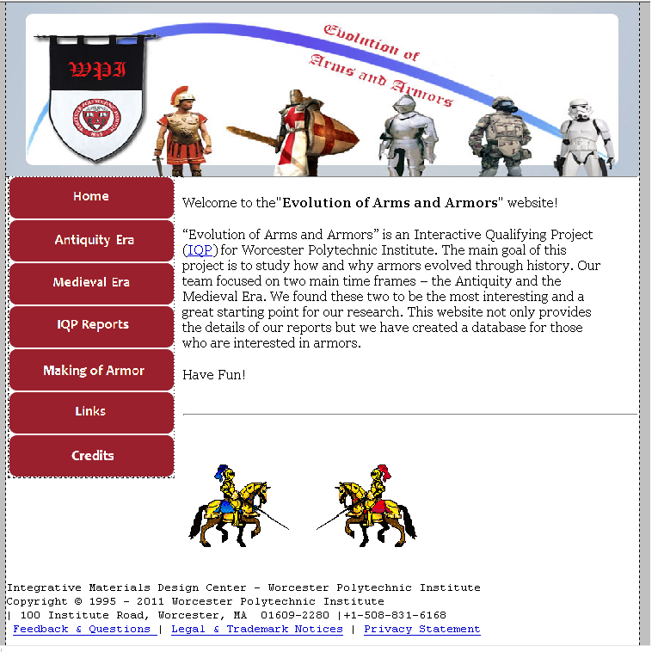

The making of armor page is now updated with pictures and videos of the actual making of our armor, here, the outlines for the shoulder pieces are shown:

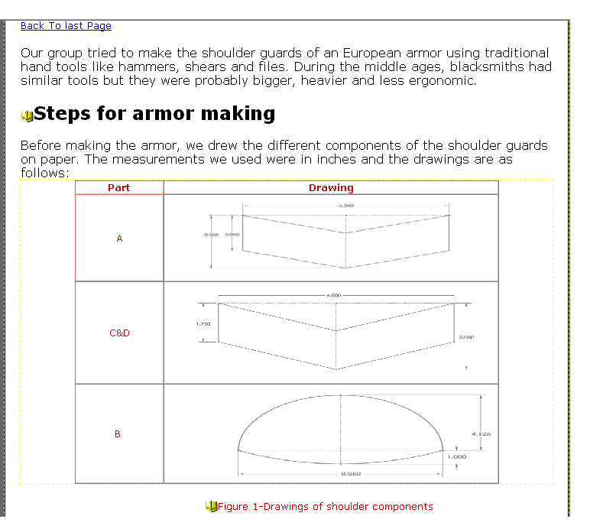

Also, we have pictures of the making of the armor, either in the shop of with Fay Butler:

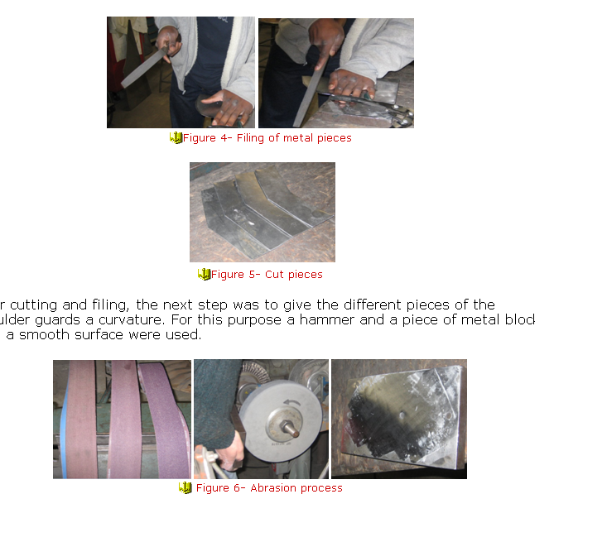

Our site also carries videos of us making the armor, either in the shop of with Fay Butler: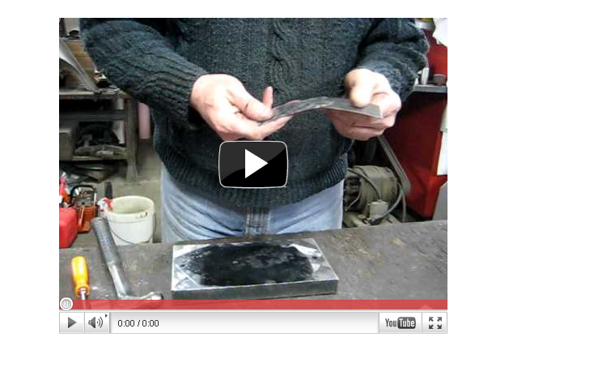

The maps are now interactive, with armor pages for the every civilization indicated on the map. The blue “Boxes” on the map are interactive hotspots, which link to the armor pages, and create links indicated on a browser by the cursor turning into a selector, like it would for any other link. Thus the maps become image maps, with multiple clickable links Here, we can see the medieval era map, as seen in dreamweaver:

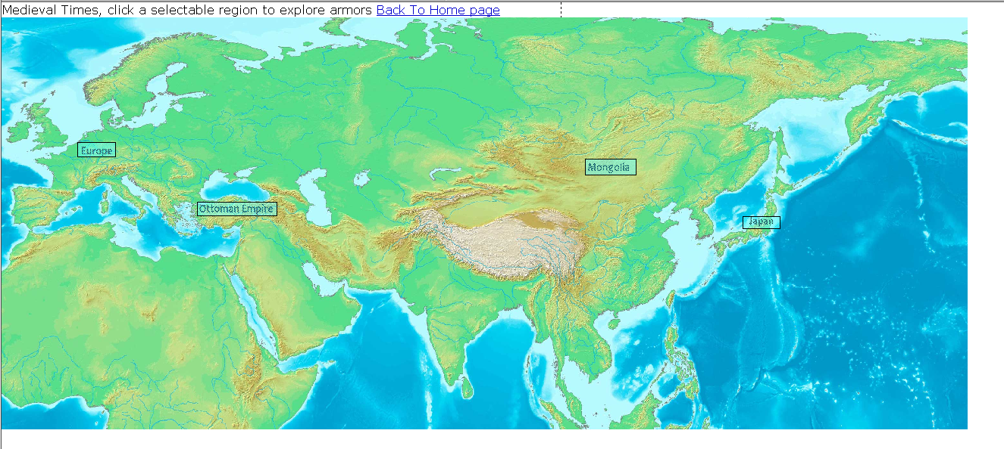

And here it is in a browser:

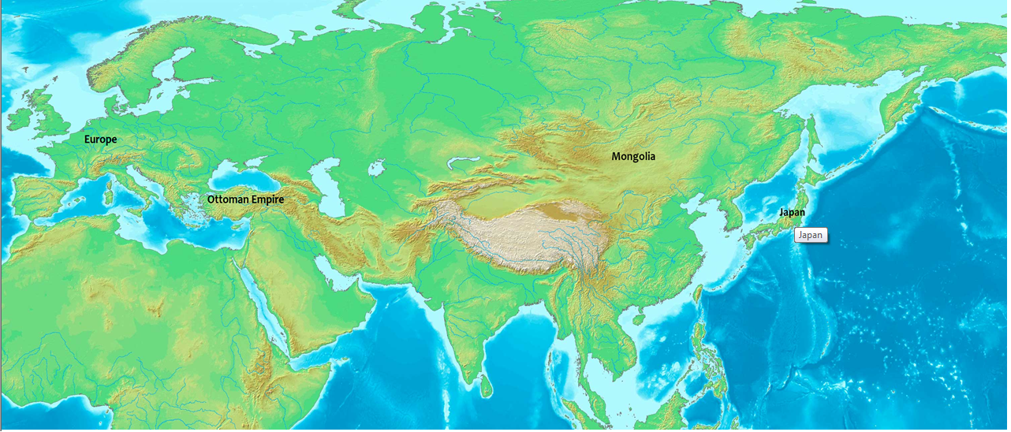

Every link on the site is titled, so that a title will appear beneath it when the mouse is stationary above it.

The armor pages themselves contain summaries of the time periods and summaries of the individual pieces of armor, with more information presented in the report. These summaries illustrate how various types of armor evolved over a short period of time in a region, for example, The helmets of Greece from 600-200 BC are shown here:

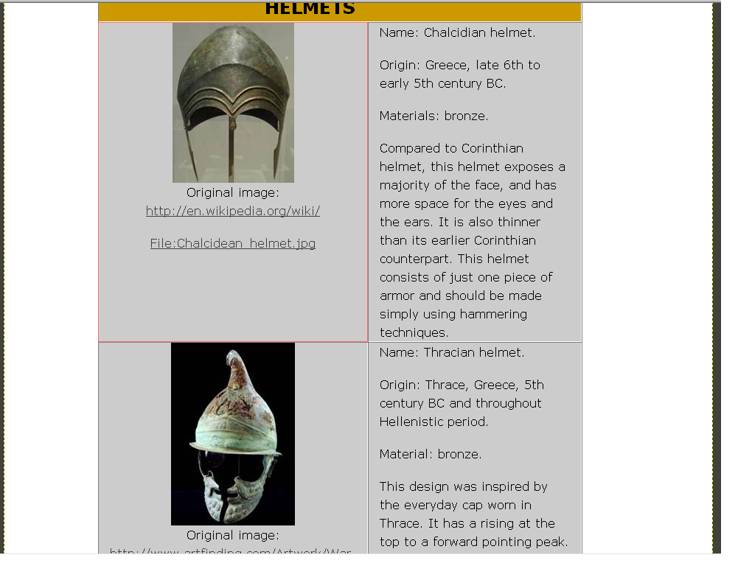

For some regions individual pieces of armor that were commonly used are discussed, such as here with the Ottoman Empire:

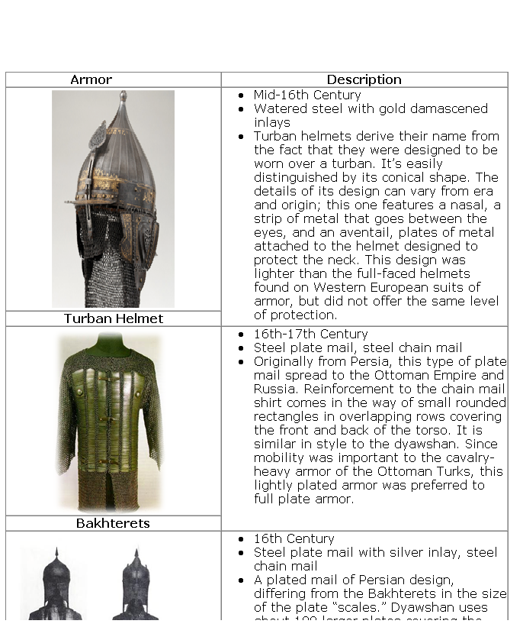

The report itself has its own page now, which will contain the final copy of the medieval and antiquity reports. Also, the links page contains links to works cited, this report, Fay Butler’s website, and much more.

Each armor page has a timeline, and for the medieval pages, these timelines appear in separate windows when the link is clicked, while the antiquity map hub has a general history. These timelines document major wars or military advancements in that area in the specific era, for example, here’s Mongolia’s medieval timeline:

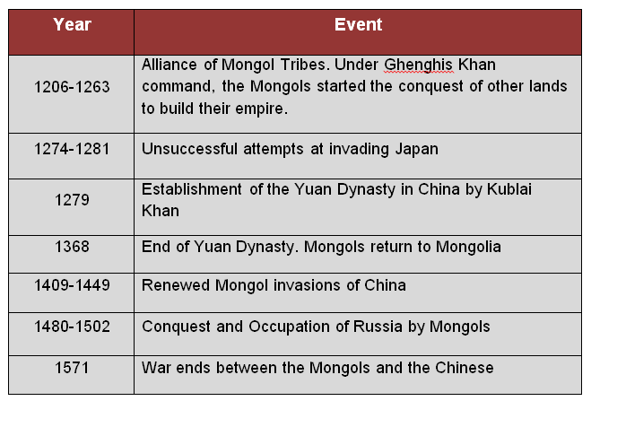

Antiquity has a series of 5 maps, two depicting west Asia, and three for Europe. These maps show civilizations that existed in the same timeframes (800-600 BC, 600-200 BC, and 200BC-400AD Europe only). Upon clicking the Antiquity button, the user is led to a hub for these maps:

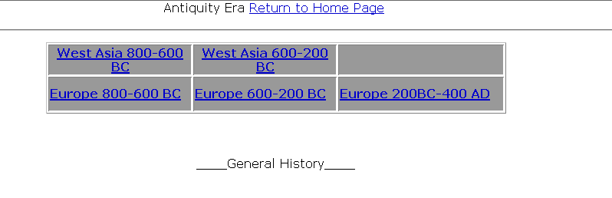

Every armor page has a jump menu on it, with the medieval pages leading to any other medieval era armor pages, for example, the Mongolia armor page’s jump menu looks like this:

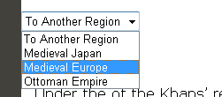

The antiquity maps and armor pages have jump menus leading to the other antiquity maps:

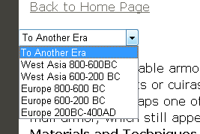

Thus, with these tools, our website was created.